Name: Arpit Mahalle
Day 23 Assignment output screenshots
Challenge 1:
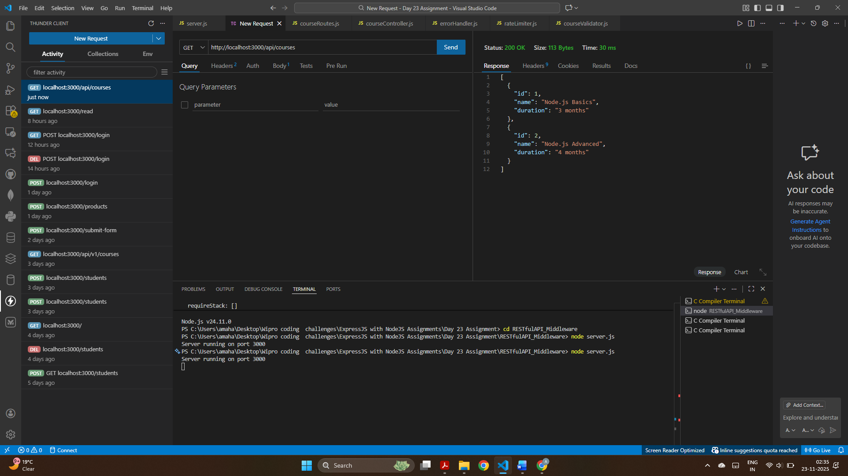
A GET request successfully returned the list of available courses stored in the in-memory array.

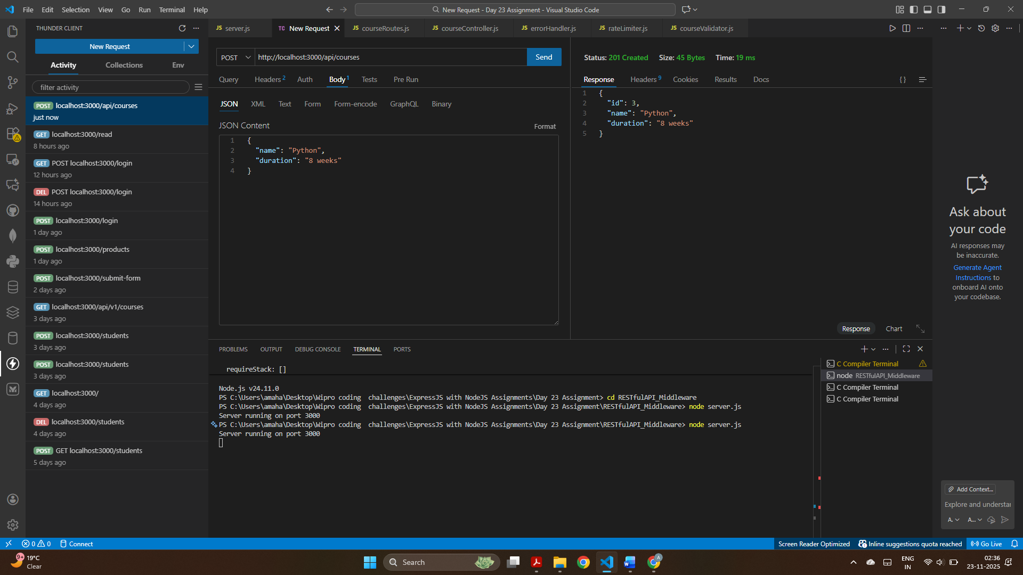
A new course (“Python – 8 weeks”) was created and added to the in-memory course list with a unique ID.

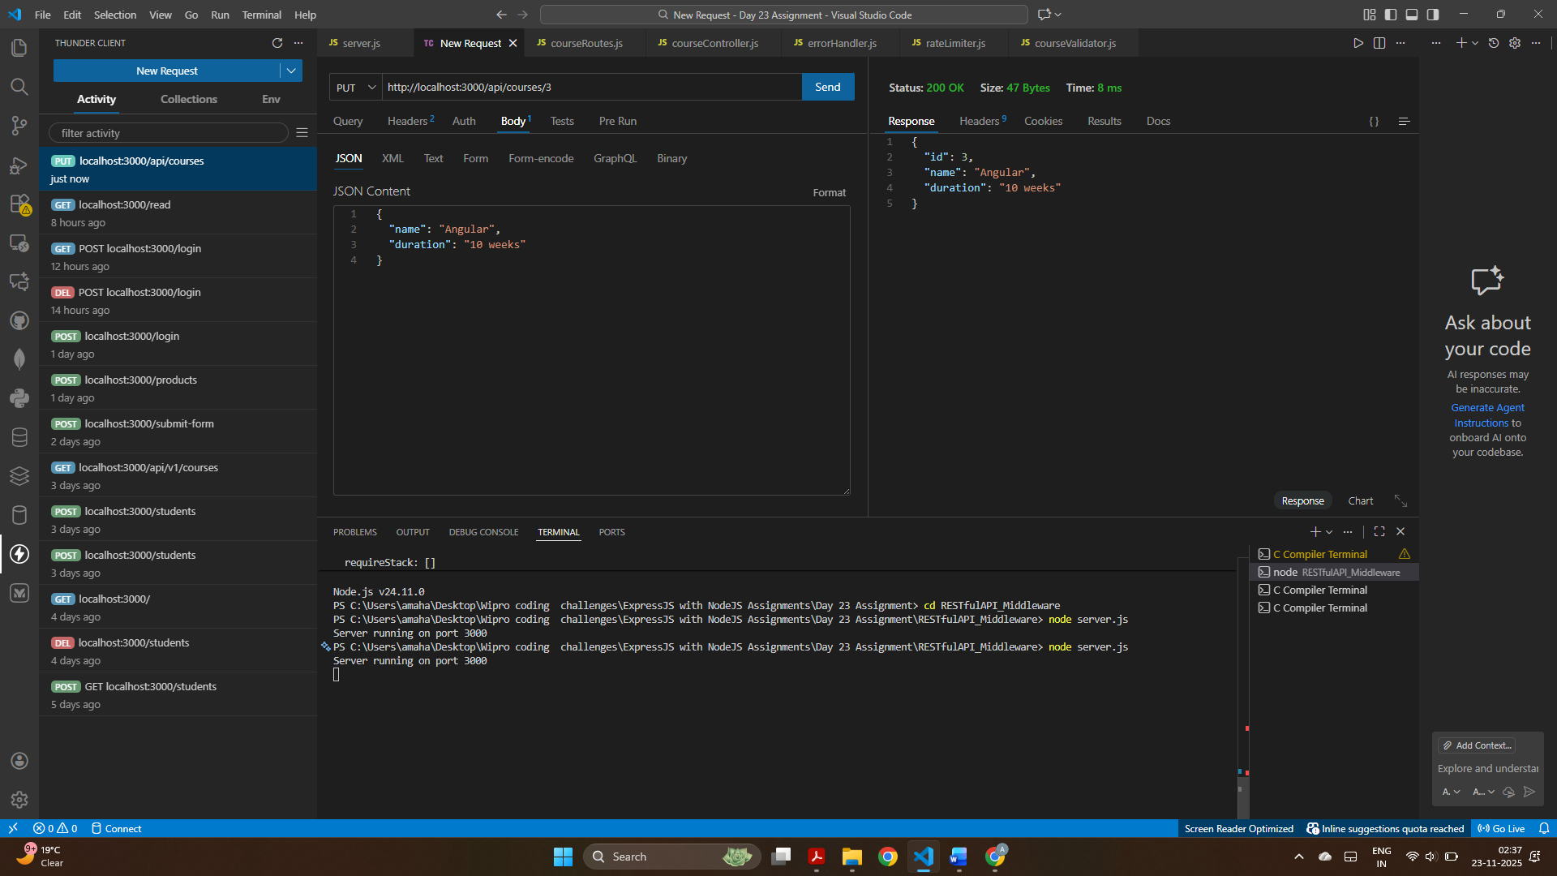
The course with ID 2 was updated to “Angular – 10 weeks,” and the updated course details were returned.

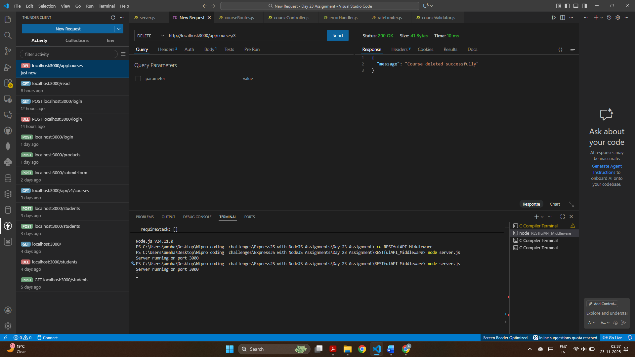
The selected course was deleted from the in-memory list, and a confirmation message was returned.

Challenge 2:
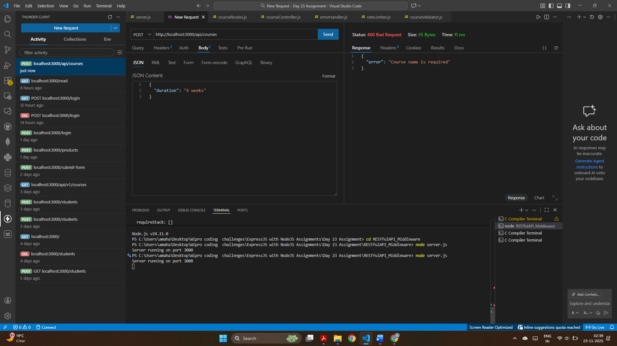
Submitting a POST request without the required name field triggered validation, returning the error: “Course name is required.”

Challenge 3:
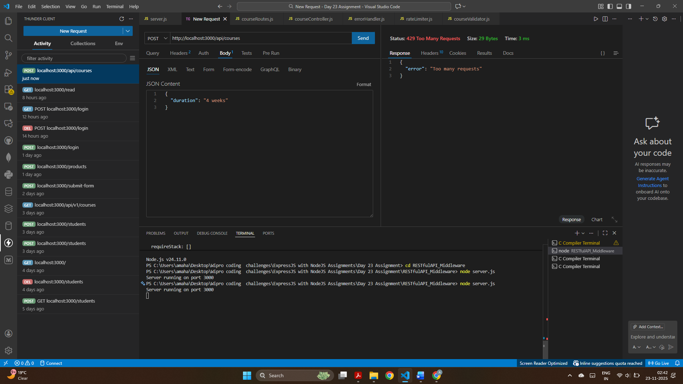
Sending more than 5 requests within one minute activated the rate-limiting middleware, resulting in the error: “Too many requests.”

